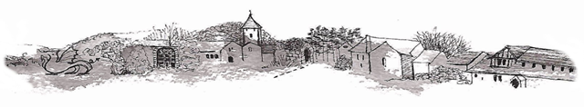Penhow Community Council
‘Good Causes’ Grant Application
Penhow Community Council (PCC) makes regular donations to local good causes which provide services and support to residents of Penhow.
The PCC will open applications from good causes annually and applications will be assessed by PCC councillors against the criterion outlined below. Good causes can apply for a maximum of £500 to support their activities within the community. Should the PCC receive a high volume of applications they may choose to support multiple good causes which will reduce the single donations to each good cause.
To apply for a donation please complete the questions below and submit it, by 31.08.2024 with any supporting documentation to clerk@penhowcommunity.org or post to: Clerk to the Council, Penhow CC, Yr Hen Berllan, Common-y-coed, Magor NP26 3AX Applications received after the closing date may not be accepted.

Applicant name

Group/organisation applying for funding

Location or residing address
Contact telephone and email
The activity  Please describe the project, activity or item you are requesting a donation for and why you require a donation. Include explanation of how you will address environmental sustainability i.e. recycling, tree planting Max 250 words |  | Criteria 1  The activity  Score 1-5
The beneficiaries  Tell us who will benefit e.g. member of the Brownies group Penhow, approximately how many people this will directly and indirectly benefit and how they will benefit e.g. social interaction. Max 100 words |  | Criteria 2  Beneficiaries  Score 1-5
The Donation  Tell us how much your total project, activity or item will cost and how much donation you would like from PCC to support this. If you are not requesting 100% donation for the cost of the project, activity or item tell us how you will fund the remainder e.g. cash in bank or ticket sales. |  | Criteria 3  Funding  Score 1-5
Capital projects  If you would like a donation towards the purchase of goods or services then also attach a quote. |  | Not scored

Criteria guidance
Each scored question will be given a score of between 1-5 by a group of no less than 4 PCC councillors. Those good causes scoring highest will receive a donation of a maximum of £500.
Criteria 1 – The activity
Applications demonstrating the activity is for Penhow residents and will deliver longer term benefits to the community and have considered environmental impact will score highest.
Criteria 2 – The beneficiaries
Applications demonstrating a high level of Penhow beneficiaries both direct and indirect and those with longer term benefits will score highest
Criteria 3 – The donation
Applications demonstrating they have alternative funding streams and require a low level contribution to their application will score highest.

